## Lesson 11 – Activity Sheet

## Getting Started

Bluetooth is a radio communication protocol that allows the transmission of data over short distances. It relies on having a transmitting device and a receiving device or devices all using the same channel or group.

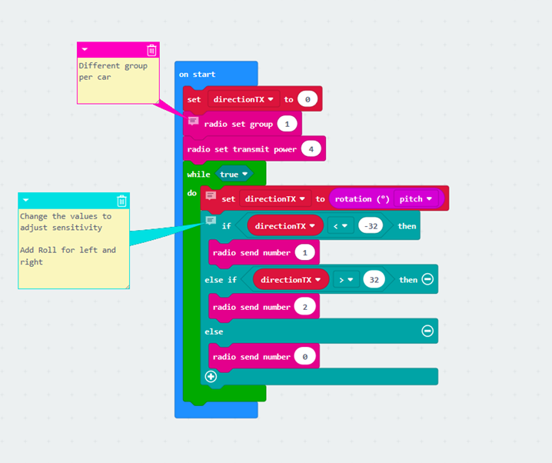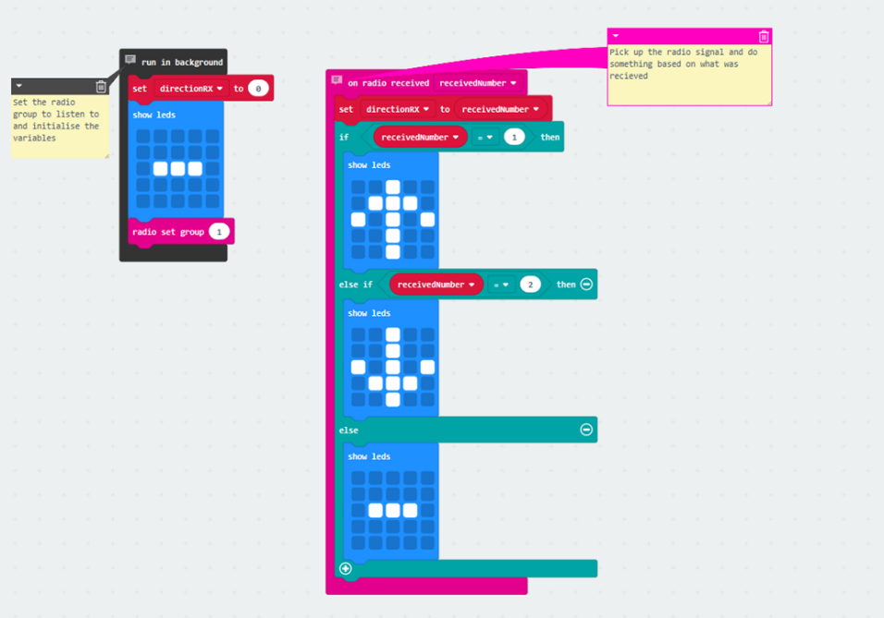

The example above uses two micro:bits on channel 1. One micro:bit transmits the signal – in this case as you pitch the micro:bit forward it will send a 1, pitch it backwards it sends a 2 and then hold it level it sends a 0.

The receiving micro:bit receives the value processes it and then displays an image accordingly.

**Try adjusting the values of the pitch being measured and see how it impacts sensitivity.**

## Success Criteria

* Be able to send a signal from one micro:bit to another
* To be able to receive a signal and process the data
* To use the signal to control movement by combining Bluetooth and sensor data

## Pro-tip

* Consider how we can use the accelerometer data to detect pitch and roll and how we could interpret this to use as steering data by using the motors

## Test Time

* Remember fail early, fail often!
* Demonstration file works correctly
* Demonstration file modified to also use roll (left/right)
* Motor control added to the receiving file for forward and backward
* Motor control added to the receiving file for left and right

## Stretch Tasks

## Adjust the sensor values so the smallest movement sets off the vehicle

## Adjust the receiving file to use a range of values – small tilt less power than larger tilt

* Time how quickly the data is sent to being received over longer distances – how will this impact your driving?
* How will interferences from other racers cause issues, experiment with groups and powers to find out how much of an impact this has

## Final thoughts

* During today’s lesson we have looked at how Bluetooth can be used to transmit and receive data.
* We have used Bluetooth to transmit values from one micro:bit to another and then processed this data.
* We have looked at how this can then be converted into a remote control for our Bit:Bot and discussed some of the problems we will encounter